Table of Contents
[MacOS] Terminal Setup 1
Part 1: Install iTerm2 2
Part 2: Install Homebrew 2
Part 3: Install Git 2
Part 4: Install Zsh 2
Part 5: Install Oh-my-zsh 2
Part 6: Install zsh-autosuggestions 3
Part 7: Install zsh-syntax-highlighting 3
Part 8: Install Powerline-fonts 3
Part 9: Make command line in iTerm2 to become beautifully 3
[Mobile + Web] web + android + iOS Setup (Real devices) 9
Part 1: Install Xcode​ 9
Part 2: Install JDK 11 9
Part 3: Install Maven 10
Part 4: Install IntelliJ Community 11
Part 5: Install Nodejs 12
Part 6: Install Android Studio 13
Part 7: Install Appium 16
Part 8: Install Appium Desktop 16
Part 9: Install Appium Inspector 16
Part 10: Install other iOS dependencies​ 16
Part 11: Set up the real iOS devices for mobile testing 17
Part 12: Install the WebDriverAgent​ 19

[MacOS] Terminal Setup
This article shows you how to set up real iOS devices to test iOS applications with automation framework using Appium
To begin with, you need to setup a macOS environment. You can not execute iOS mobile testing in Windows or Linux.

Part 1: Install iTerm2
iTerm2 is a replacement for Terminal and the successor to iTerm. It works on Macs with macOS 10.14 or newer. iTerm2 brings the terminal into the modern age with features you never knew you always wanted.
You can download iTerm2 from iTerm2 website: https://iterm2.com/downloads.html
Unzip the download file, then move iTerm2 to Applications folder.

Part 2: Install Homebrew
Open iTerm2. Copy below command:
/bin/bash -c "$(curl -fsSL https://raw.githubusercontent.com/Homebrew/install/HEAD/install.sh)"
Paste the command in iTerm2, then press Enter
Part 3: Install Git
Copy bellow command:
brew install git
Paste the command in iTerm2, then press Enter
After intalled git done, you can check version of git by using command in iTerm2
git --version
Part 4: Install Zsh
Copy bellow command:
brew install zsh
Paste the command in iTerm2, then press Enter
After intalled git done, you can check version of git by using command in iTerm2
zsh --version
Part 5: Install Oh-my-zsh
Copy bellow command:
sh -c "$(curl -fsSL https://raw.github.com/ohmyzsh/ohmyzsh/master/tools/install.sh)"
Paste the command in iTerm2, then press Enter
Part 6: Install zsh-autosuggestions
Copy bellow command:
git clone https://github.com/zsh-users/zsh-autosuggestions ${ZSH_CUSTOM:-~/.oh-my-zsh/custom}/plugins/zsh-autosuggestions
Paste the command in iTerm2, then press Enter

Part 7: Install zsh-syntax-highlighting
Copy bellow command:
git clone https://github.com/zsh-users/zsh-syntax-highlighting.git ${ZSH_CUSTOM:-~/.oh-my-zsh/custom}/plugins/zsh-syntax-highlighting
Paste the command in iTerm2, then press Enter
Part 8: Install Powerline-fonts
You can copy and paste these commands to your iTerm2
git clone https://github.com/powerline/fonts.git --depth=1
cd fonts
./install.sh
cd ..
rm -rf fonts
Part 9: Make command line in iTerm2 to become beautifully
Copy bellow command:
vim .zshrc
The command means open .zshrc file by Vim editor. Paste the command in iTerm2, then press Enter, it will show as bellow image:
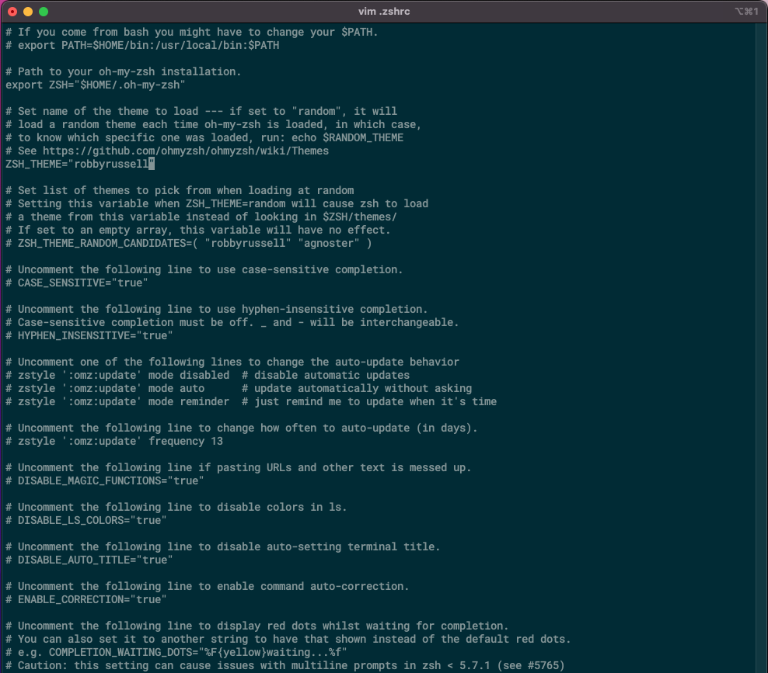
Press “i” key on your keyboard to change vim to insert mode. Then pls use Down arrow key on your keyboard to move to ZSH_THEME=’robbyrussell’. Pls change ‘robbyrussell’ to ‘agnoster’ as bellow image:
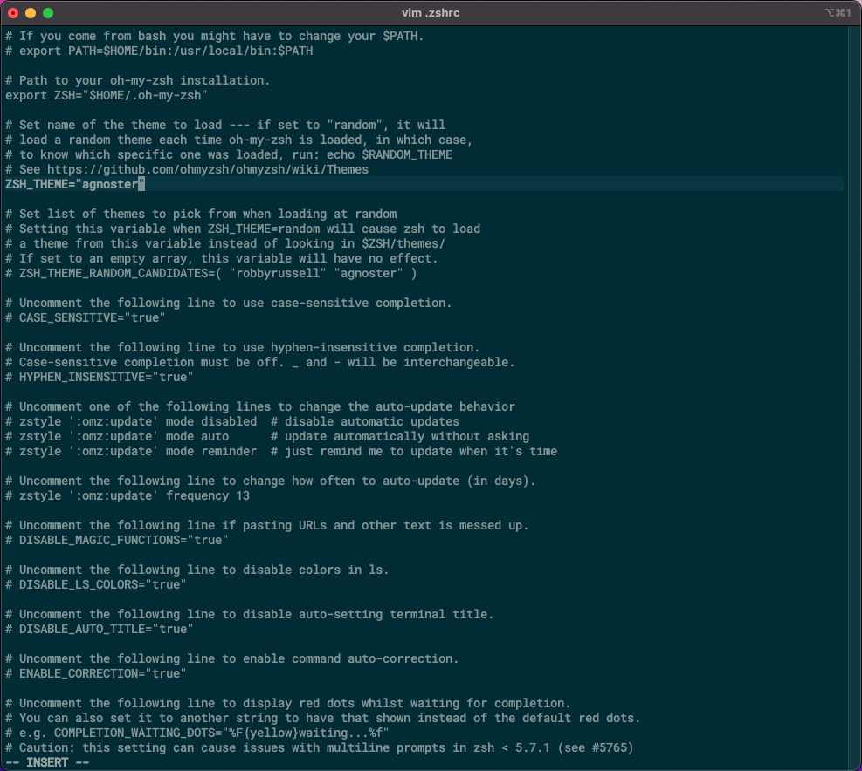
Pls continue to use Down arrow key to move to plugins=(git)
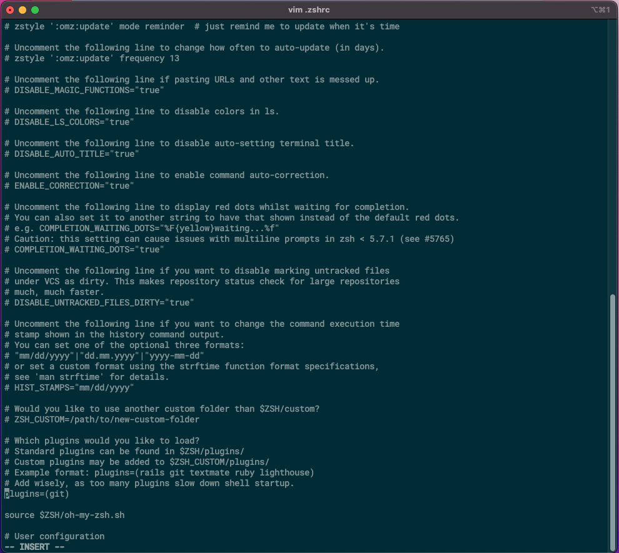
Add zsh-syntax-highlighting, zsh-autosuggestions to plugins
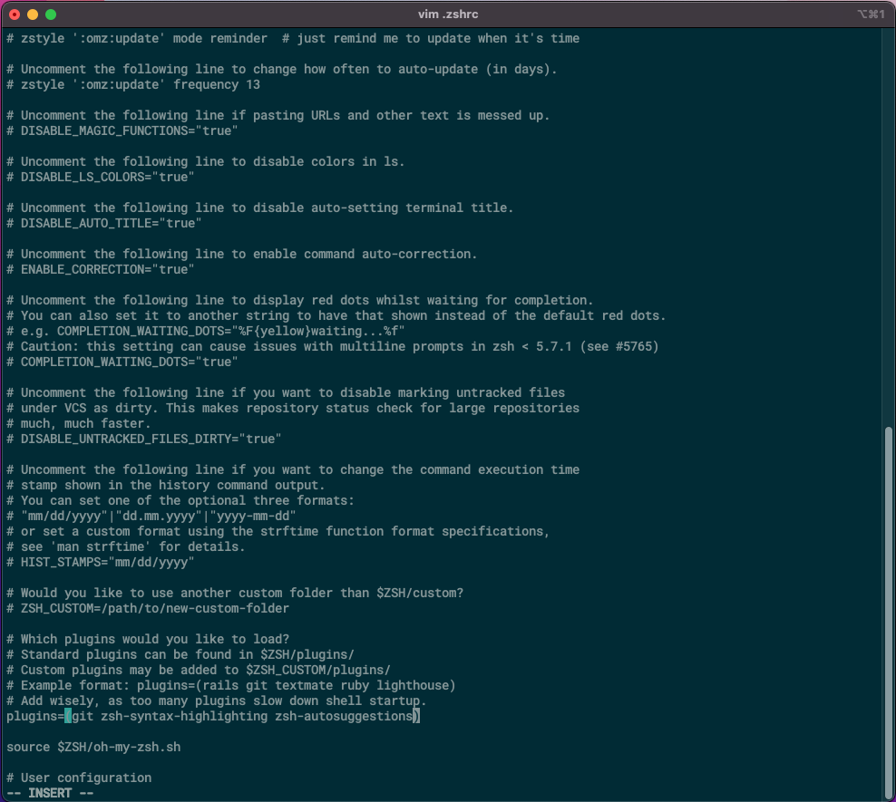
Press ESC key, then press :wq! to exit vim editor
Note: w means save .zshrc file
q means quit
! mean force => q! means force quit
Back to command line mode, pls use bellow command:
source .zshrc
Move to Preferences of iTerm2 by clicking iTerm2 at upper left corner, near Apple icon
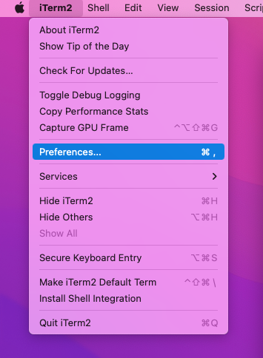
On Preferences, choose Profiles
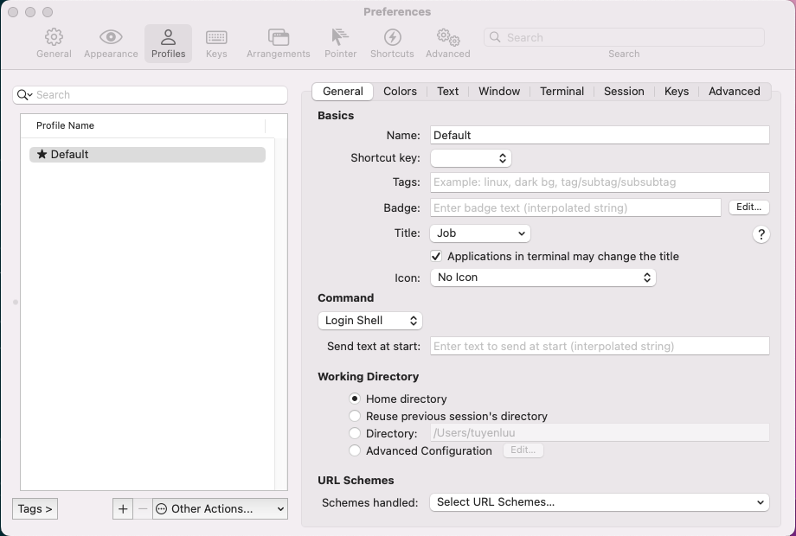
Change Colors Presets to Solarized Dark in Colors tab
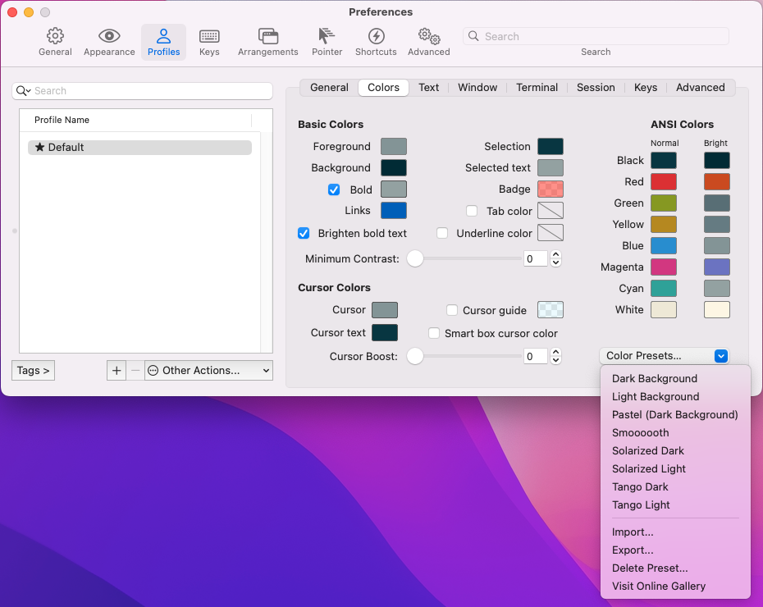
Change Font to Roboto Mono Medium for Powerline, font size to 14 in Text tab
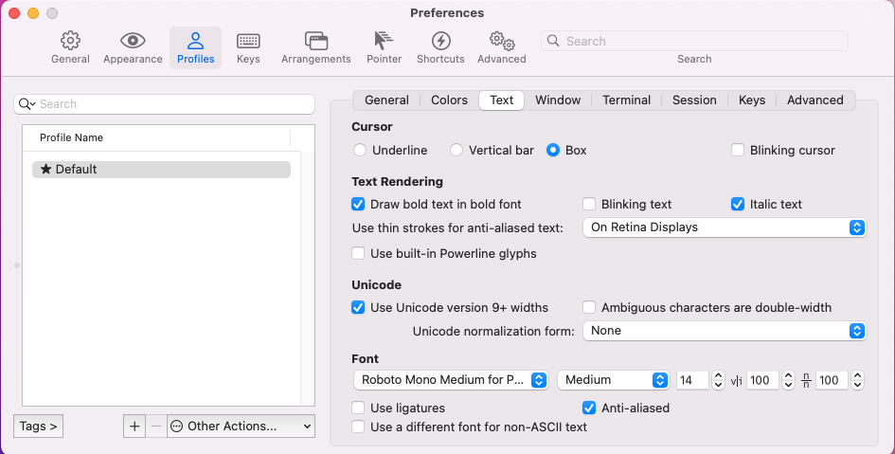
Restart iTerm2, and open again
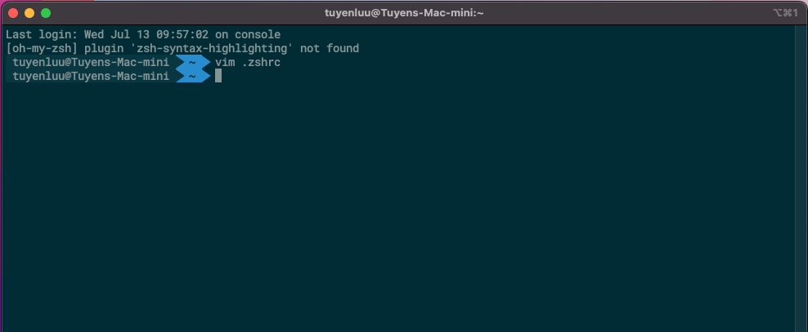

[Mobile + Web] web + android + iOS Setup (Real devices)
This article shows you how to set up real iOS devices, real android devices, real web to test iOS applications, android application, and web application with automation framework using Selenium, Appium
To begin with, you need to setup a macOS environment. You can not execute iOS mobile testing in Windows or Linux.

Part 1: Install Xcode​
Install Xcode version 10.2 or newer. You can download Xcode from the App Store or the Apple Developer website: https://developer.apple.com/xcode/.
Note: Xcode must support the current version of your iOS device.
Part 2: Install JDK 11
Pls access the website https://www.oracle.com/java/technologies/javase/jdk11-archive-downloads.html to download JDK 11 for MacOS.
After downloaded JDK 11, pls install it
Next, we will set JAVA_HOME environment variable on MacOS
Open iTerm2, and input bellow command:
vim .zshrc
Use Down arrow key to move to # User configuration
Press I key on your keyboard to change Insert mode, then add these commands bellow #User configuration
export JAVA_HOME=/Library/Java/JavaVirtualMachines/jdk-11.0.15.jdk/Contents/Home
export PATH=$JAVA_HOME/bin:$PATH
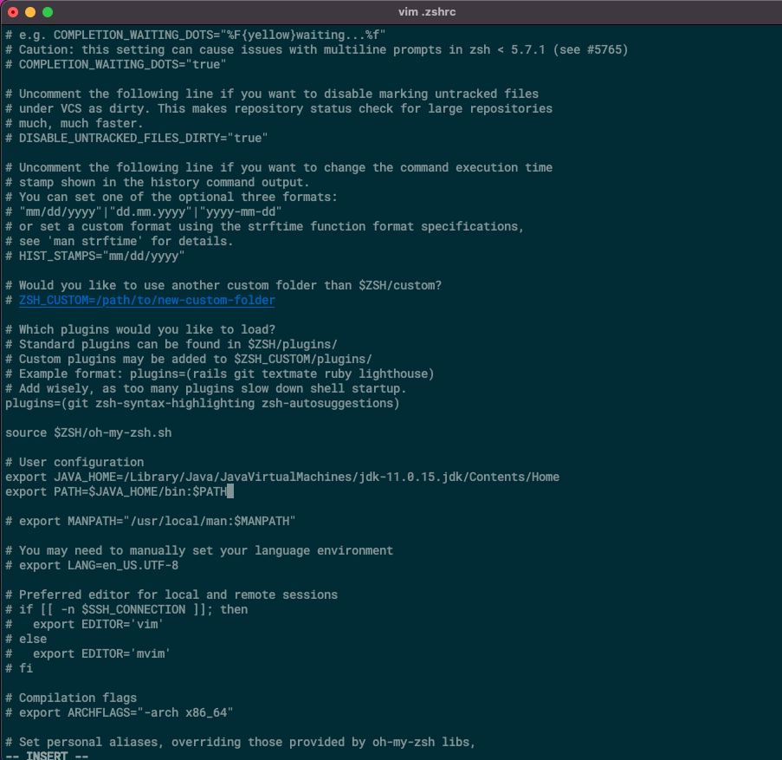
Press ESC key, then press :wq! to exit vim editor.
Back to command line mode, pls use bellow command:
source .zshrc
Input java --version to check version of java. If iTerm2 show version of java, you setup JAVA_HOME environment variable successfully.
Part 3: Install Maven
Pls access the website https://maven.apache.org/download.cgi to download apache-maven-3.8.6-bin.zip.
Move apache-maven-3.8.6-bin.zip to a folder (Example: /User/tuyenlm/Maven)
Unzip the file in /User/tuyenlm/Maven
Next, we will set MAVEN_HOME environment variable on MacOS
Open iTerm2, and input bellow command:
vim .zshrc
Use Down arrow key to move to # User configuration
Press I key on your keyboard to change Insert mode, then add these commands bellow #User configuration
export JAVA_HOME=/Library/Java/JavaVirtualMachines/jdk-11.0.15.jdk/Contents/Home
export MAVEN_HOME=/Users/tuyenluu/Maven/apache-maven-3.8.6
export PATH=$JAVA_HOME/bin:$PATH
export PATH=$MAVEN_HOME/bin:$PATH
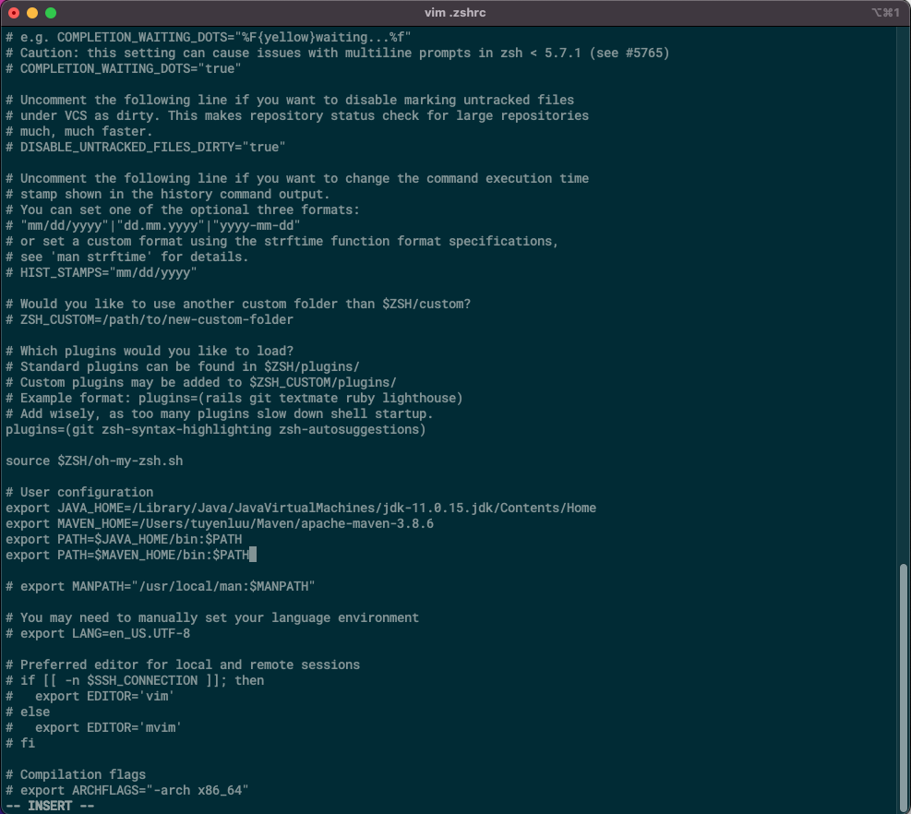
Press ESC key, then press :wq! to exit vim editor.
Back to command line mode, pls use bellow command:
source .zshrc
Input mvn --version to check version of maven. If iTerm2 show version of maven, you setup MAVEN_HOME environment variable successfully.
Part 4: Install IntelliJ Community
Pls access the website https://www.jetbrains.com/idea/download/#section=mac to download IntelliJ IDEA Community for MacOS, then install it.
Part 5: Install Nodejs
Pls access the website https://nodejs.org/en/download/ to download Nodejs for MacOS, then install it
Next, we will set NODE_HOME environment variable on MacOS.
Open iTerm2, and input bellow command:
vim .zshrc
Use Down arrow key to move to # User configuration
Press I key on your keyboard to change Insert mode, then add these commands bellow #User configuration
export JAVA_HOME=/Library/Java/JavaVirtualMachines/jdk-11.0.15.jdk/Contents/Home
export MAVEN_HOME=/Users/tuyenluu/Maven/apache-maven-3.8.6
export NODE_HOME=/usr/local/bin/node
export PATH=$JAVA_HOME/bin:$PATH
export PATH=$MAVEN_HOME/bin:$PATH
export PATH=$NODE_HOME:$PATH
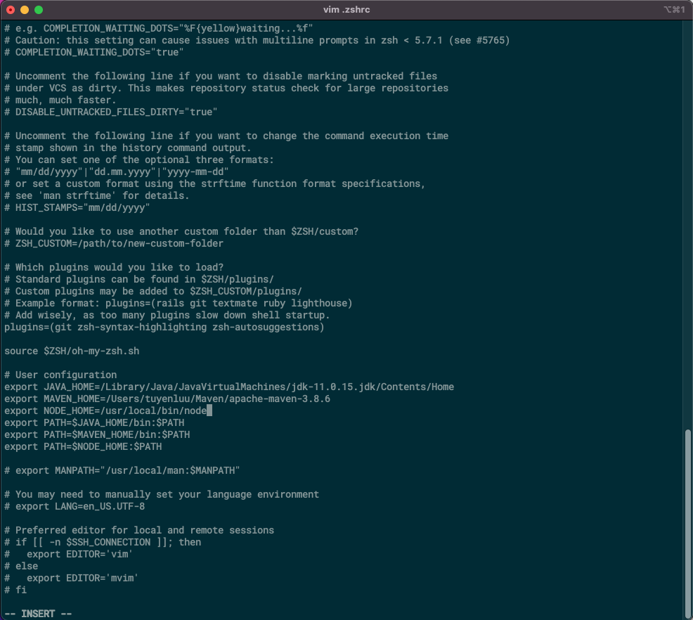
Press ESC key, then press :wq! to exit vim editor.
Back to command line mode, pls use bellow command:
source .zshrc
Part 6: Install Android Studio
Pls access the website https://developer.android.com/studio to download Android Studio for MacOS, then install it
Next, we will set ANDROID_HOME environment variable on MacOS.
First, we need to get path of SDK. Open Android Studio
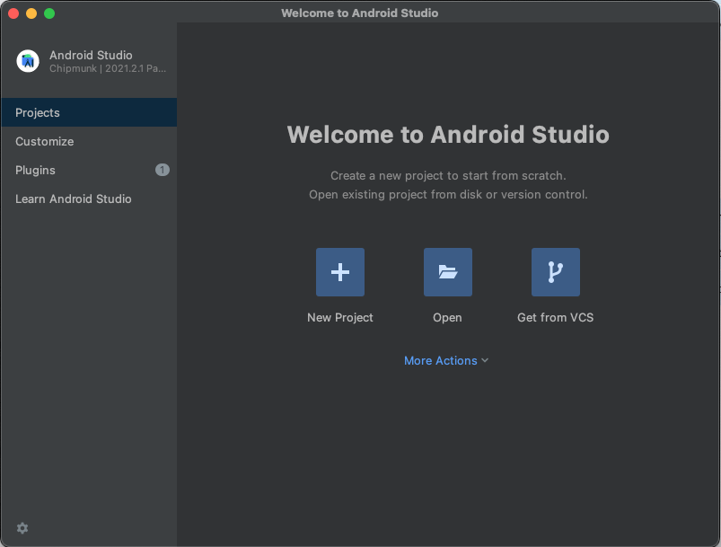
Click More Actions -> SDK Manager
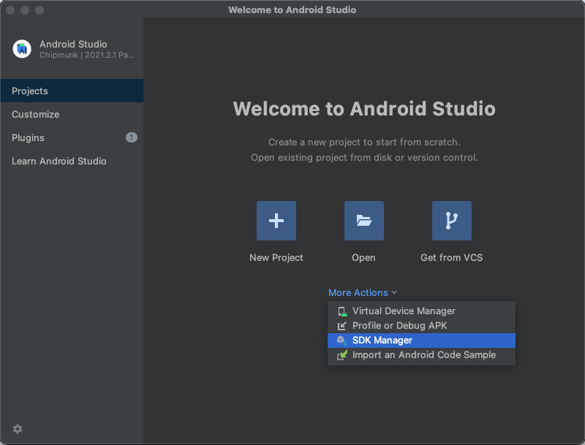
Copy path of SDK in Android SDK Location
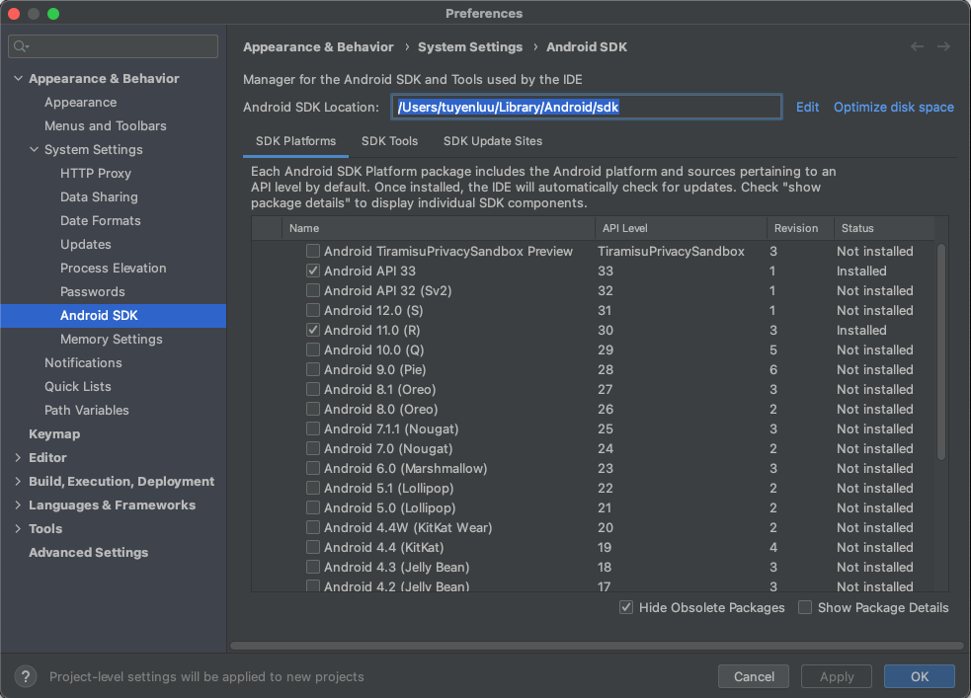
Open iTerm2, and input bellow command:
vim .zshrc
Use Down arrow key to move to # User configuration
Press I key on your keyboard to change Insert mode, then add these commands bellow #User configuration
export JAVA_HOME=/Library/Java/JavaVirtualMachines/jdk-11.0.15.jdk/Contents/Home
export MAVEN_HOME=/Users/tuyenluu/Maven/apache-maven-3.8.6
export NODE_HOME=/usr/local/bin/node
export ANDROID_HOME=/Users/tuyenluu/Library/Android/sdk
export PATH=$JAVA_HOME/bin:$PATH
export PATH=$MAVEN_HOME/bin:$PATH
export PATH=$NODE_HOME:$PATH
export PATH=$ANDROID_HOME/platform-tools:$PATH
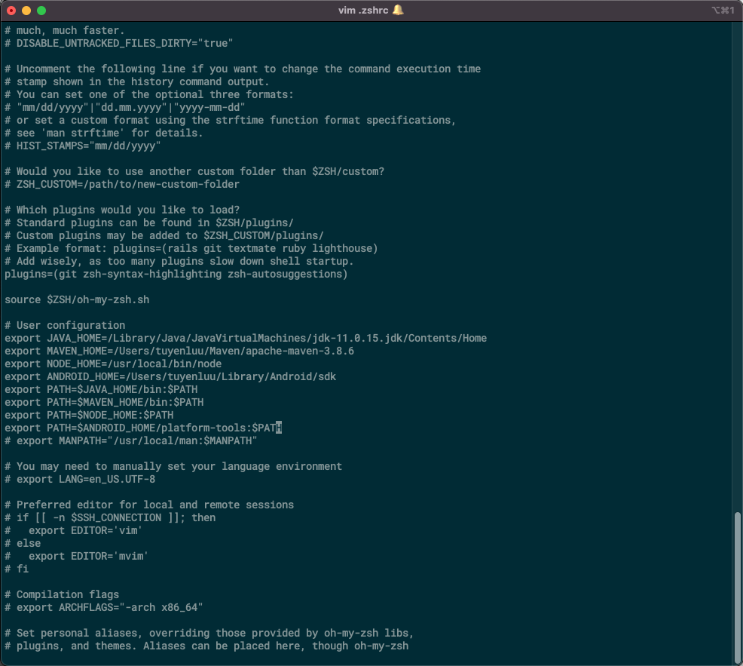
Press ESC key, then press :wq! to exit vim editor.
Back to command line mode, pls use bellow command:
source .zshrc

Part 7: Install Appium
Open iTerm2, and input bellow command:
npm install -g appium
Input appium --version to check version of appium. If iTerm2 show version of appium, you installed appium successfully.

Part 8: Install Appium Desktop
Pls access the website https://github.com/appium/appium-desktop/releases to download Appium Desktop for MacOS, then install it

Part 9: Install Appium Inspector
Pls access the website https://github.com/appium/appium-inspector/releases to download Appium Inspector for MacOS, then install it

Part 10: Install other iOS dependencies​
  - ios-deploy version 1.9.4 or newer. You can learn more about ios-deploy in this Github project: ios-deploy. To install ios-deploy via Homebrew, copy and paste the command-line argument as below:
brew install ios-deploy
  - usbmuxd version 1.0.10 or newer. You can learn more about usbmuxd in this Github project: usbmuxd. To install usbmuxd via Homebrew, copy and paste the following command-line arguments in this order:
brew install --HEAD usbmuxd
brew unlink usbmuxd
brew link usbmuxd
  - libimobiledevice version 1.2.0 or newer. You can learn more about libimobiledevice on the libimobiledevice website: libimobiledevice. To install libimobiledevice via Homebrew, copy and paste the following command-line arguments in this order:
brew install --HEAD libimobiledevice
brew unlink libimobiledevice
brew link libimobiledevice
  - For Appium versions older than 1.20.0, you need to install Carthage. You can learn more about Carthage in this Github project: Carthage. To install Carthage via Homebrew, copy and paste the command-line argument below:
brew install carthage
  - For Appium versions older than 1.15.0, you also need to install ios-webkit-debug-proxy. You can learn more about ios-webkit-debug-proxy in this Github project: ios-webkit-debug-proxy. To install ios-webkit-debug-proxy via Homebrew, copy and paste the command-line argument as below:
brew install ios-webkit-debug-proxy

Part 11: Set up the real iOS devices for mobile testing
- You have enrolled in the Apple Developer Program. To learn more about the Apple Developer Program enrollment, you can refer to this Apple document: Enrollment.
- Any device for development with Xcode must be listed in the Apple Developer Portal. To learn about listing your device in Apple Developer Portal, you can refer to this wikiHow document: How to Add a New Device to Your Apple Developer Portal.
- In Xcode > Preferences > Account, click Add (+) to enter your Apple Developer Account ID and password.
- Connect your iOS devices to your computer via a USB cable. Confirm to accept or trust the phone.
- To enable UI Automation on the device, navigate to Settings > Developer. In the UIAutomation section, turn on the setting for Enable UI Automation.
- If you want to execute your tests using Safari on iOS (mobile browser), you will need to enable the following settings in Settings > Safari > Advanced:
- JavaScript
- Web Inspector
- Remote Automation
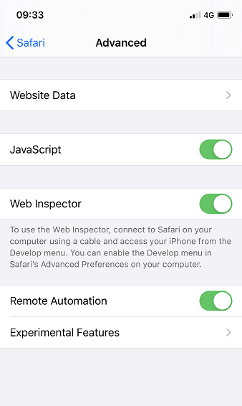

Part 12: Install the WebDriverAgent​
The WebDriverAgent is a WebDriver server used to control iOS devices remotely.
To install the WebDriverAgent manually, follow these steps:
- In Xcode > Preferences > Account, click Add (+) to enter your Apple Developer Account ID and password.
- To navigate to the location of the WebDriverAgent, open iTerm2, copy and paste the command line argument below:
cd /usr/local/lib/node_modules/appium/node_modules/appium-webdriveragent
For Appium version 1.14.2 or older, copy the following command instead:
cd /usr/local/lib/node_modules/appium/node_modules/appium-xcuitest-driver/webdriveragent
- After going to the WebDriverAgent location, run the following command to initialize the WebDriverAgent project:
mkdir -p Resources/WebDriverAgent.bundle
For Appium version older than 1.20.0, you also need to run the following script on the same terminal:
sh ./Scripts/bootstrap.sh -d
- Open Finder and choose Go -> Go To Folder…, type /usr/local/lib/node_modules/appium/node_modules/appium-webdriveragent. In the opened folder, double-click the WebDriverAgent.xcodeproj file to open it in Xcode.
- After opening WebDriverAgent.xcodeproj file in Xcode, you need to build the IntegrationApp app. To do so, follow these steps:
- Select the IntegrationApp target. In the Signing & Capabilities section, check the Automatically manage signing box, then choose a team added in Step 1.
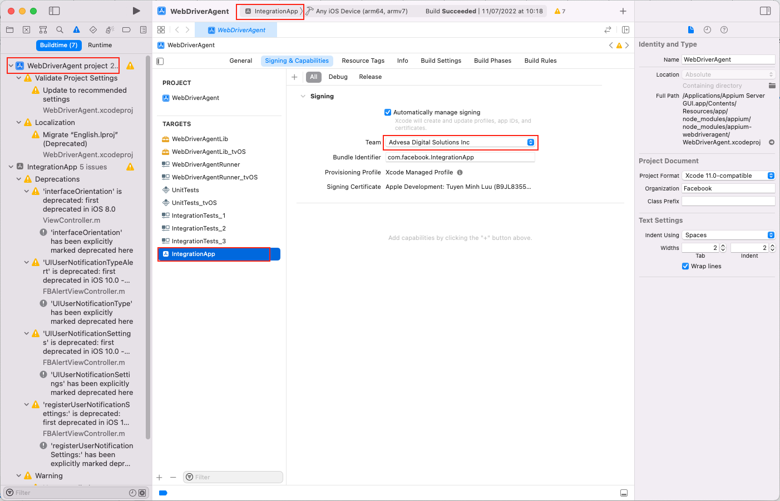
- On the menu bar, select Product > Build.
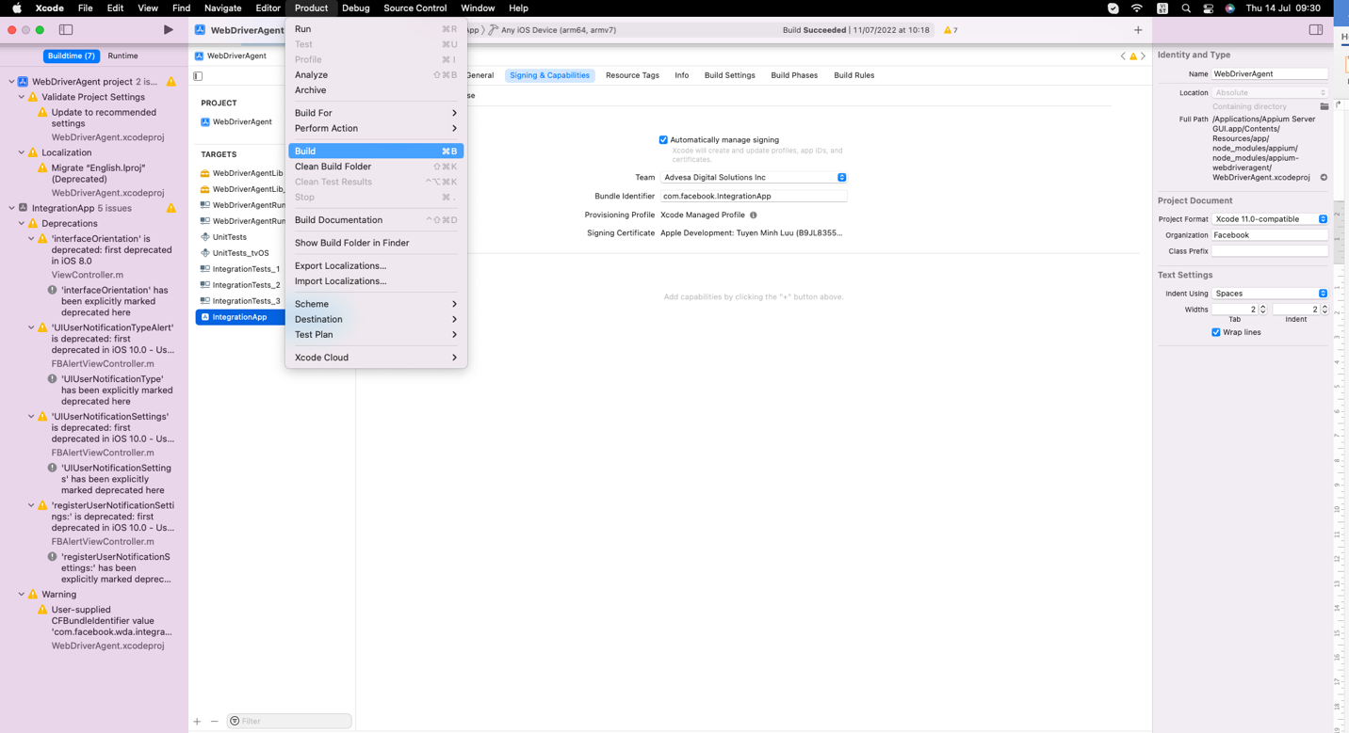
Result: You have successfully built the IntegrationApp target.
- Next, build the WebDriverAgentLib target. Follow these steps:
- Select the WebDriverAgentLib target. In the Signing & Capabilities section, check the Automatically manage signing box, then choose a team added in Step 1.
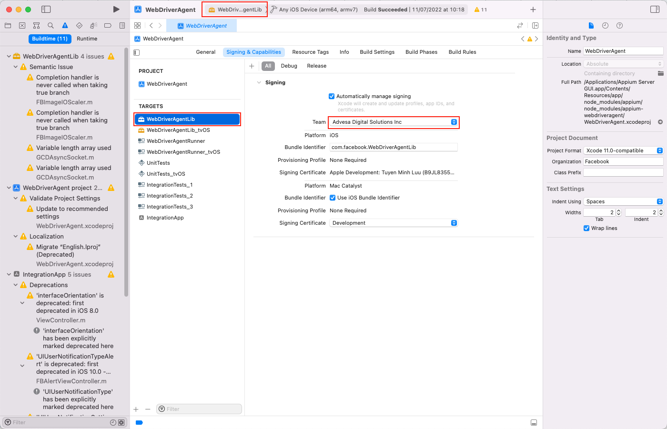
- On the menu bar, select Product > Build.
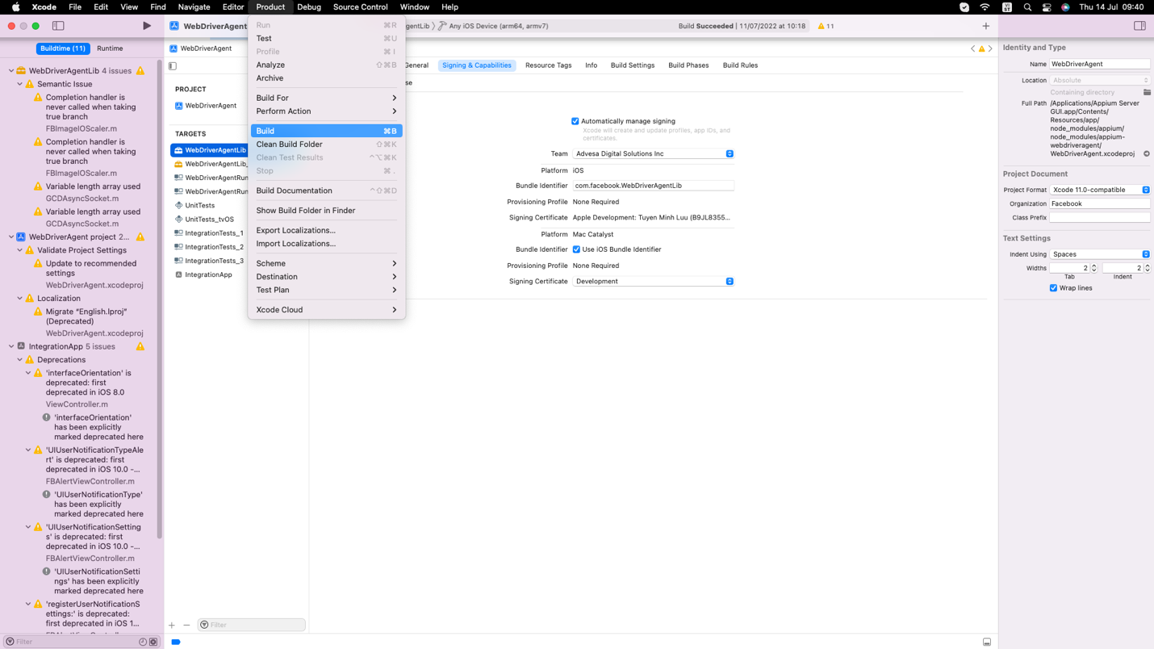
Result: You have successfully built the WebDriverAgentLib target.
- Finally, you need to build the WebDriverAgentRunner target. Follow these steps:
- Select the WebDriverAgentRunner target. In the Signing & Capabilities section, check the Automatically manage signing box, then choose a team added in Step 1.
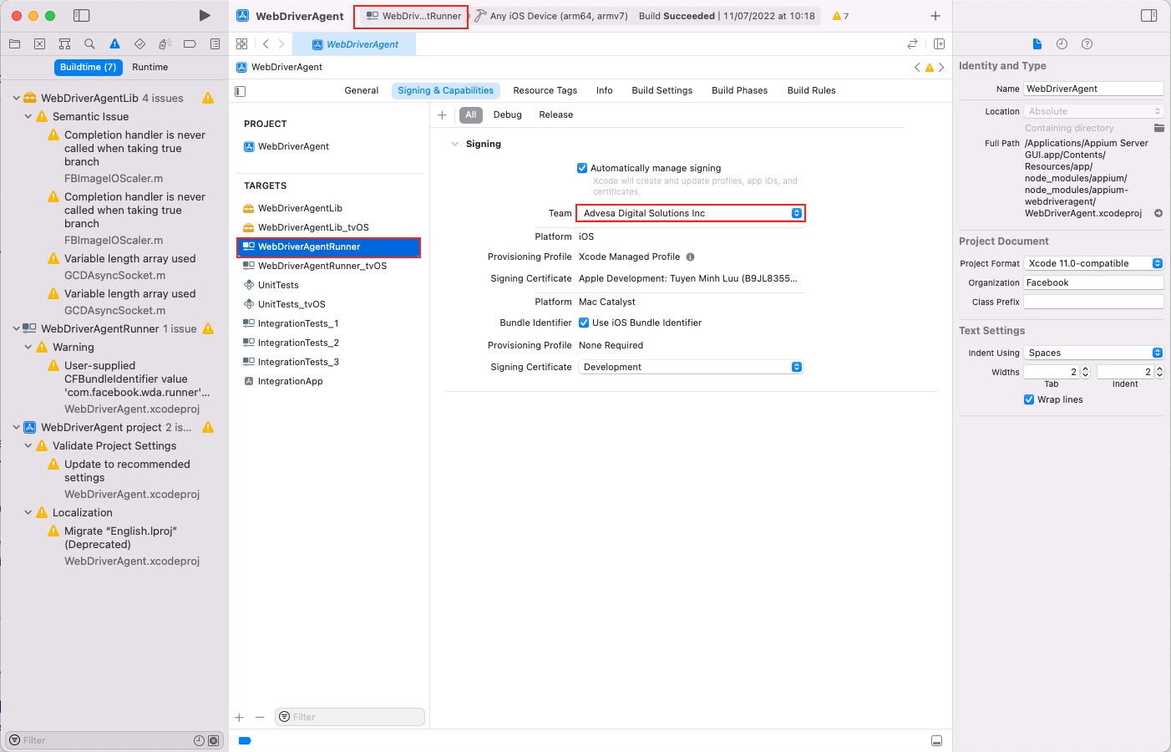
- On the menu bar, select Product > Build.
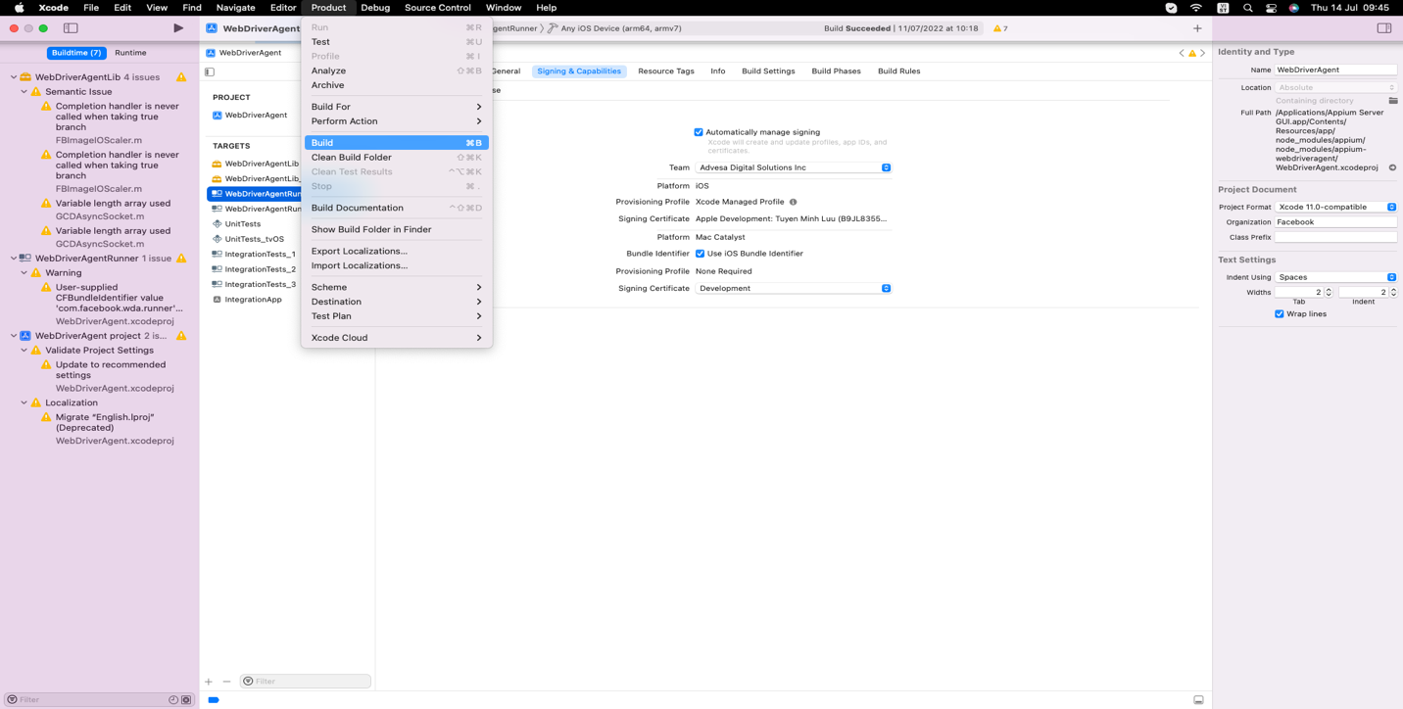
Result: You have successfully built the WebDriverAgentRunner target

